**WRITER PROGRAM**

import java.io.BufferedWriter; import java.io.FileWriter; import java.io.IOException; public class WriterProgram {

public static void main(String[] args) { String filePath = "message.txt";

String message = "Hello from Dhiraj!";

try (BufferedWriter writer = new BufferedWriter(new FileWriter(filePath))) { writer.write(message);

System.out.println("Message written to " + filePath);

} catch (IOException e) { e.printStackTrace();

}

}

}

**ReaderProgram:**

import java.io.BufferedReader; import java.io.FileReader; import java.io.IOException; public class ReaderProgram {

public static void main(String[] args) { String filePath = "message.txt";

try (BufferedReader reader = new BufferedReader(new FileReader(filePath))) { String line;

while ((line = reader.readLine()) != null) { System.out.println("Message read from " + filePath + ": " + line);

}

} catch (IOException e) { e.printStackTrace();

}

}

}

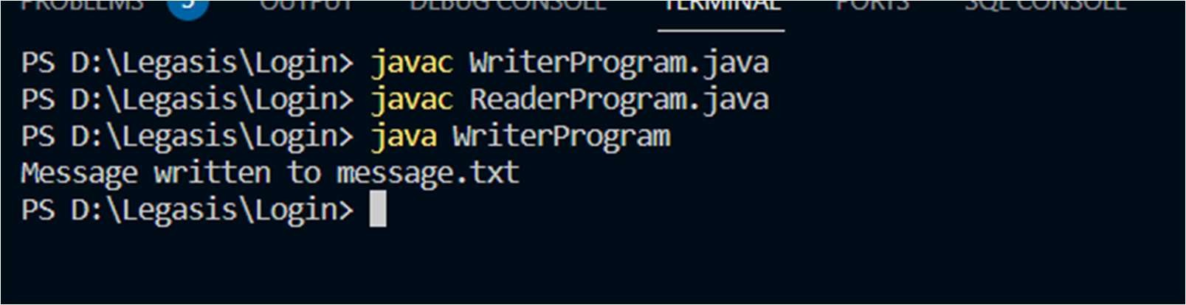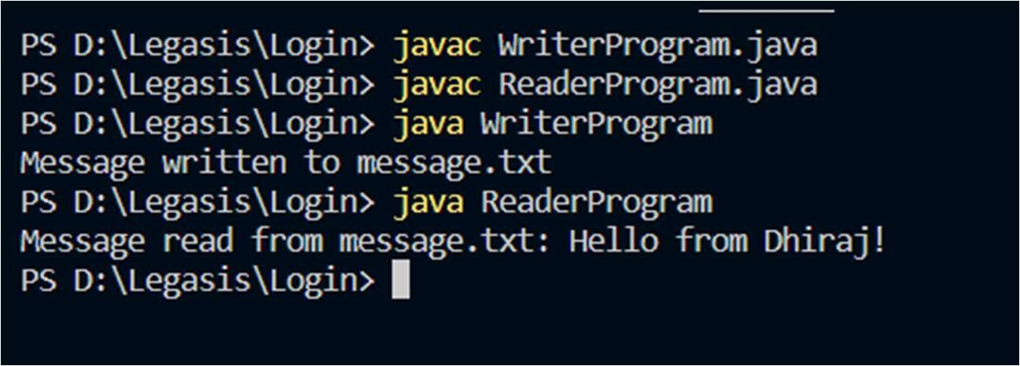

Python :-

**# WriterProgram**

**class WriterProgram:**

**@staticmethod**

**def main():**

**file_path = "message.txt"**

**message = "Hello from Raj!"**

**try:**

**with open(file_path, 'w') as writer:**

**writer.write(message)**

**print("Message written to", file_path)**

**except IOError as e:**

**print("Error:", e)**

**# ReaderProgram**

**class ReaderProgram:**

**@staticmethod**

**def main():**

**file_path = "message.txt"**

**try:**

**with open(file_path, 'r') as reader:**

**for line in reader:**

**print("Message read from", file_path + ":", line.strip())**

**except IOError as e:**

**print("Error:", e)**

**if __name__ == "__main__":**

**WriterProgram.main()**

**ReaderProgram.main()**